|  |
| --- |
| **Department of Software Engineering**  **Mehran University of Engineering and Technology, Jamshoro** |

|  |  |  |  |
| --- | --- | --- | --- |
| **Course: SWE121 – Object Oriented Programming** | | | |
| **Instructor** | Mr. Asmatullah | **Practical/Lab No.** | 11 |
| **Date** | 23-09-2022 | **CLOs** | CLO-3 |
| **Signature** |  | **Assessment Score** | 1 Marks |

|  |  |
| --- | --- |
| **Topic** | **Building GUI components** |
| **Objectives** | * To understand the inheritance hierarchy of components and containers: Component,Container, Panel, Window, Frame, Dialog etc. * Write code to use and display the different GUI control components such as the: Botton, Canvas, checkbox, Choice, Label, List, TextField and TextAre. * To understand the use of java.awt.Component class and methods setVisible(),setEnable(),getSize(),setForeGround(), setBackground() etc. |

|  |
| --- |
| **Lab Discussion: Theoretical concepts and Procedural steps** |

**Tools:**  Java Development Kit, Text Pad, Netbeans, Eclipse

**Theory**

Outline

* Introduction to GUI, basic javax,swing components.
* To learn how to use graphical user interface in Java programs.
* Describe containers and how to apply components such as Label, List, Button,Checkbox,TextField etc in the container.

**Java Swing tutorial** is a part of Java Foundation Classes (JFC) that is *used to create window-based applications*. It is built on the top of AWT (Abstract Windowing Toolkit) API and entirely written in java.

Unlike AWT, Java Swing provides platform-independent and lightweight components.

The javax.swing package provides classes for java swing API such as JButton, JTextField, JTextArea, JRadioButton, JCheckbox, JMenu, JColorChooser etc.

### Difference between AWT and Swing

There are many differences between java awt and swing that are given below.

### **Hierarchy of Java Swing classes**

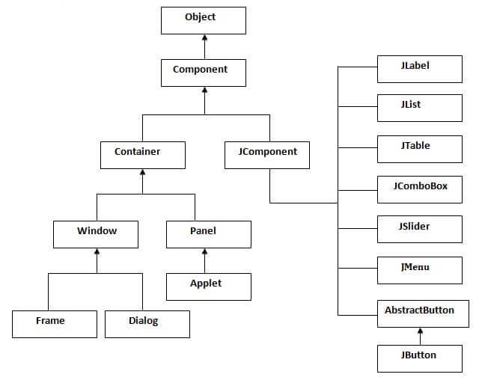

|  |
| --- |
| **Department of Software Engineering**  **Mehran University of Engineering and Technology, Jamshoro** |

|  |  |  |  |
| --- | --- | --- | --- |
| **Course: SWE121 – Object Oriented Programming** | | | |
| **Instructor** | Mr. Asmatullah | **Practical/Lab No.** | 12 |
| **Date** | 23-09-2022 | **CLOs** | CLO-3 |
| **Signature** |  | **Assessment Score** | 1 Marks |

|  |  |
| --- | --- |
| **Topic** | **Java Event handling** |
| **Objectives** | * To understanding the event handling mechanism provided by Java. * Write code to implement listener classes and methods, and in listener methods extract information from the events to determine the affected component, mouse position, nature and time of event. * Demonstrate the event handling in AWT by implementing the appropriate listeners. * Illustrate the usage of event Adapter classes. |

|  |
| --- |
| **Lab Discussion: Theoretical concepts and Procedural steps** |

**Tools:**  Java Development Kit, Text Pad, Netbeans, Eclipse

**Theory**

Outline

* Explain the concept behind event handling
* Discuss event handling related to mouse events and various listeners such ActionListener, MouseListener, MouseMotionListener etc.
* Learn how to develop event driven application.

**What is an Event?**

Any program that utilizes GUI (graphic user interface) like windows-written Java application is event oriented. Event defines any object's change in status. For example: press a button, enter a character in textbox, click or drag a mouse, etc.

Change in the state of an object is known as event i.e. event describes the change in state of source. Events are generated as result of user interaction with the graphical user interface components. For example, clicking on a button, moving the mouse, entering a character through keyboard,selecting an item from list, scrolling the page are the activities that causes an event to happen.

### **Components of Event Handling**

### **Event handling has three main components,**

* **Events:**  An event is a change in state of an object.
* **Events Source:**An event source is an object that generates an event.
* **Listeners:** A listener is an object that listens to the event. A listener gets notified when an event occurs.

### **Java Event classes and Listener interfaces**

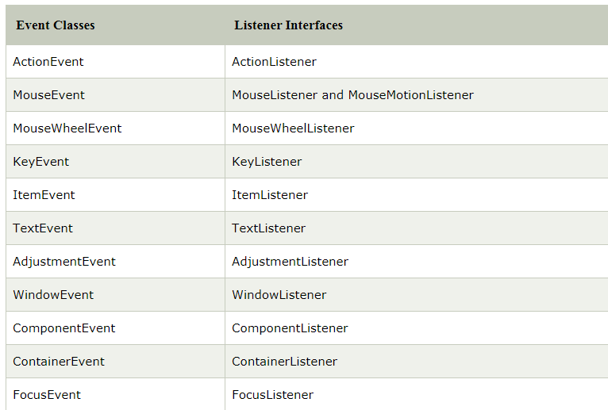

### **Steps to perform Event Handling**

Following steps are required to perform event handling:

1. Register the component with the Listener

### **Registration Methods**

For registering the component with the Listener, many classes provide the registration methods. For example:

* **Button**
  + public void addActionListener(ActionListener a){}
* **MenuItem**
  + public void addActionListener(ActionListener a){}
* **TextField**
  + public void addActionListener(ActionListener a){}
  + public void addTextListener(TextListener a){}
* **TextArea**
  + public void addTextListener(TextListener a){}
* **Checkbox**
  + public void addItemListener(ItemListener a){}
* **Choice**
  + public void addItemListener(ItemListener a){}
* **List**
  + public void addActionListener(ActionListener a){}
  + public void addItemListener(ItemListener a){}

|  |
| --- |
| **Lab Tasks** |

1. Write an GUI Application that capture following information of a Student :

1. Reg. No. 2. Name 3. Batch 4. Section

5. Gender (must be a choice object) eg Radio Button

6. Qualification (must be a choice object) eg Check Box

7. Address (must have multiple lines) eg TextArea

8. Country (must be list item) eg ComboBox

This application must have 2 buttons on the screen one is for Save and one for Display, when user selects Save then all fields will be initialized and data will be stored in JSON file. On pressing display button all the data will be shown on new frame.

Create a colorful GUI by adding background color or image to buttons and frame.

This task contain 3 Marks. Two to complete task with JSON file and colorfull GUI and one to upload it on github.

A demo screen is shown below.

